**Recipe Hub - A CrowdSource Recipe Collection**

**Capstone Project - CS 69099**

Team Sigma

* Charles Drolet - [cdrolet@kent.edu](mailto:cdrolet@kent.edu)
* Akshaya Katha - [akatha1@kent.edu](mailto:akatha1@kent.edu)
* Md Kawsher Mahbub - [mmahbub@kent.edu](mailto:mmahbub@kent.edu)
* Bharathi Donku - [bdonku@kent.edu](mailto:bdonku@kent.edu)
* Sai Aravind Reddy Thippanuri - [sthippa4@kent.edu](mailto:sthippa4@kent.edu)
* Akheel Syed - [asyed18@kent.edu](mailto:asyed18@kent.edu)

May 3rd, 2025

**Executive Summary**

This project serves to create a web-based application in which users can create an account in order to access a recipe sharing platform and share their love of cooking. The motivation behind the idea of this project came from the desire to create a platform where culture can be explored by users of various nationalities with ease. Food and cuisine are a strong aspect of every culture, therefore developing an application that allows users around the globe to share their culture while exploring new ones represent the motivation behind this project.

Various features were implemented in order to allow the users to share and learn recipes from the web application. Such features include:

1. Sign-up and login page
2. Home page where recipes snapshots are seen (including picture, recipe title, and average rating)
3. Various filtering options to search for specific recipes
   1. Users can filter by simple search, type of cuisine, popular keyword, healthy & diet options, meal type, or average rating type
   2. Filters can be removed using the “Reset all” button
4. Surprised Me! recipe button
   1. This button brings the user to a random recipe generated by theMealDB api
5. Rotating Recipes at the top of the home page
   1. All shared recipes will rotate over time allowing the user to access recipes without the need to scroll through the home page
6. User profile page where user can see all of the recipes that shared, and make any updates to their profile
7. Individual recipe page
   1. Accessed by clicking on the “View recipe” button, users can see the details to recreate the recipe at home.
   2. If a reference video was provided when the user shared the recipe, then it can be played directly from this page.
   3. Users also have to option to save the recipe to their “Favorites”, download/print the recipe, share via email, rate the recipe, and write/see comments
8. Favorites page
   1. This page is user specific and mimics the home page, but only shows the recipes that were marked by the given user as “favorites”

Additionally, throughout the development of the project, many challenges were faced to ensure that the application was user friendly and had an appealing look. The goal was to produce a web application that is inviting to users around the globe, while keeping an easy, appealing interface to not restrict anyone from utilizing the web application. Throughout the development, various bugs were faced and overcame to deliver the web application found on the Cassini website. Significant accomplishments include developing the home page in a format that was easy to navigate and visually appealing, as well as implementing theMealDB api to generate surprise recipes for users who wish to explore more than what is offered on the application.

**Problem Statement**

This project attempts to solve the various problems that are seen in the world of recipe sharing. The most significant problems that are faced within this realm is the rapid accumulation of recipe books, and the constant ads seen in various websites presenting recipes. Recipe books can be pricey and are often the work of a singular chef, thus reducing the variety across the recipe one can learn. If one seeks to learn various cultures through food, oftentime many books are required, thus increasing the cost and storage needed. The other common alternative revolves around accessing individual recipes via Google search. This can be particularly useful when seeking a specific recipe, but many times a person will lose the recipe they once accessed if they do not bookmark the page. Additionally, the various websites those recipes appear on contain various ads that often block the content and can be frustrating to deal with. Therefore, the project of Recipe Hub attempts to combine the benefits of having clearly defined recipes, as seen in culinary books, with the ease of access of the recipes found online. With the application, users can eliminate the purchase of recipe books, drastically reduce their research time, and navigate the culinary world without having to worry about constant pop-up ads.

Furthermore, for this project, Stephanie (lead chef in Rosie’s Dining Hall at Kent State University), our shareholder helped determine the point to make the user experience significantly better while providing various insights on how to address the target audience with success. For this project, the intended users are everyone that shares a love for the culinary world and seeks to expand their knowledge of the fantastic culture the world has to offer through food.

The problem aimed to solve in this project is important and interesting for two significant reasons. Firstly, by developing an application promoting the interaction between users, we want to promote the development of a strong community for users that share a strong passion for the culinary world. Secondly, this project is highly interesting as it promotes users to share their culture and expand their knowledge of the world by exploring the culinary world.

**System Overview & Solution Description**

For this project, the front-end was developed using Flask, which is a highly performant and flexible open-source framework for the development of web applications. The reason behind this selection originates from the flexibility of Flask as well as the familiarity with the development of Flask web application. For the back-end of this project, the selection made was to employ MongoDB for its powerful nature and simplicity of use. In order to have the web application running, various coding languages were used. HTML, CSS, JavaScript, Bootstrap, and Python languages were used to develop and allow the application to be up and running on the Cassini server. While HTMl is used to present the web page format as seen in the application, CSS, JavaScript and Python serve to connect the features developed to the Cassini server hosting our project.

By utilizing Flask as the front-end for our web application, we considered the trade-offs of using a more simple framework that may be outperformed by other frameworks available. However, due to its high familiarity and open-sourceness, the application was developed with more ease than utilizing a more complex framework. For a web application as developed in this project, Flask shows a significant level of performance to allow a smooth user experience with the application.

**Development Process**

Throughout the development of this project, many milestones were achieved and the project followed a development cycle that allowed for easy updates and progress. By utilizing GitHub issues and Kanban board, the project development process became simple and easy to see progress. Major milestones that our team are proud of accomplishing include, but not limited to, the following:

1. Development of a homepage that is simple to navigate and visually appealing
   1. This is our first significant milestones as it marked the beginning of UI that is not only visually appealing, but also simple to navigate
2. Development of filtering options on the homepage
   1. This arguably is one of the most significant milestones reached as it allows users to filter through the various recipes presented on the web page with ease.
3. Development of the User “profile” page
   1. Another significant development in our project as this not only allowed users to access the posts they have made, but also allowed the development of user specific “favorites” recipes.
4. Implementation of theMealDB api recipe generator
   1. This idea came towards the later end of the project development, but allows users to access a randomly generated recipe and expand their culinary knowledge.

The role of every member of the team consisted of developing, helping, and testing all features to ensure that the project evolved smoothly. By utilizing GitHub codespace, all members were able to add and collaborate on the development of the Recipe Hub web application, while allowing all members to not be responsible for unique roles.

**Implementation Details**

Our project follows the traditional structure of web application development in which a main algorithm controls the deployment of the application while being supported by the various HTML code to layout the project onto an appealing web page. The main code “app.py” contains all the calls to code and layouts (found under the templates) to allow the deployment of our web application. Furthermore, all UI image and layout are saved under the static folder to allow the look seen on the web application.

The Crowd Recipe Collection project consists of several important components and algorithms that power the platform:

#### 1. User Authentication & Session Management

* Flask-Login is used for handling user sessions.
* login_user() and @login_required decorators protect routes.
* Passwords are hashed using werkzeug.security.

#### 2. Recipe Recommendation

* Recipes may be recommended based on:
  + Tags (cuisine type, ingredient match)
  + User favorites
  + Popularity (views or likes count from MongoDB)

#### 3. MongoDB Queries & Aggregations

* MongoDB is used to:
  + Store users, recipes, reviews, favorites.
  + Perform text search and tag-based filtering.
* Aggregation pipelines (e.g., $match, $group, $sort) power analytics features like trending recipes.

#### 4. Form Handling and Validation

* Flask-WTF and WTForms validate forms for:
  + Recipe submission
  + User registration and login
  + Review posting

#### 5. Image Uploads

* Flask-Uploads or manual file handling with secure_filename() stores recipe images in /static/uploads/.

#### 6. Dynamic Routing and Recipe Detail Rendering

* recipe_detail.html is populated dynamically via:  
   Python, CopyEdit  
  recipe = recipes.find_one({"_id": ObjectId(recipe_id)})

### **Structure of the Codebase or Repository**

Below is the general structure of the Flask-based project:

CrowdSourceRecipe/

├── app.py # Main Flask app

├── config.py # Configuration variables

├── requirements.txt # Required Python packages

├── static/

│ └── images/ # Static recipe images and backgrounds

├── templates/

│ ├── layout.html # Base template

│ ├── home.html # Homepage showing all recipes

│ ├── login.html # Login page

│ ├── register.html # Registration page

│ ├── recipe_detail.html # Single recipe display

│ ├── add_recipe.html # Recipe submission form

├── models/

│ └── recipe.py # Schema/model logic for recipes (if used)

├── forms/

│ └── recipe_form.py # WTForms definitions

├── routes/

│ ├── auth_routes.py # Login/register/logout

│ └── recipe_routes.py # Add/view/search recipes

└── .env # MongoDB credentials (if using dotenv)

**Diagrams**

To better illustrate the functionality, relationships, and architectural design of the *Recipe Hub* web application, three key diagrams were created: a Flowchart of User Actions, an Entity Relationship (ER) Diagram, and a UML Class Diagram. These diagrams provide both high-level and detailed views of how the system operates and how components interact with one another.

### **Flowchart of User Actions**

This flowchart presents the typical user journey through the Recipe Hub application. Starting from the **Home Page**, users can navigate to **Login** or **Sign-up**, which enables session-based access. Once logged in, users can explore recipes via filtering and search options, view recipe details, post their own recipes, and interact with community features such as rating, reviewing, and saving favorites.

This diagram helps visualize the overall interaction design and ensures a user-friendly, intuitive experience. It was especially helpful in aligning the interface with our functional requirements and guiding UI design decisions.

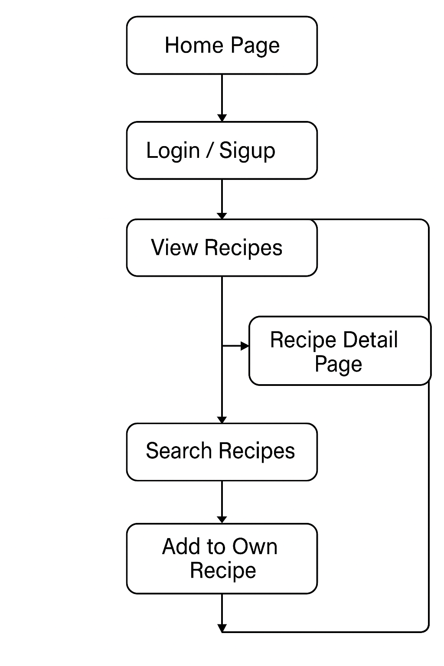

Fig 1: Flowchart of User Actions

**Entity Relationship (ER) Diagram**

The ER diagram defines the data schema and how different entities are logically connected in the application. The main entities are:

* **User**: Stores login credentials and profile information.
* **Recipe**: Stores details such as title, ingredients, instructions, tags, and media.
* **Review**: Represents ratings and comments left by users on recipes.
* **Favorite**: Represents recipes that users have marked for quick access.

Relationships:

* A **User** can create many **Recipes**.
* A **User** can write multiple **Reviews**, each linked to a **Recipe**.
* A **User** can have multiple **Favorites**, each referencing a **Recipe**.

This ER model directly influenced our MongoDB schema design and helped ensure consistency across data collections.

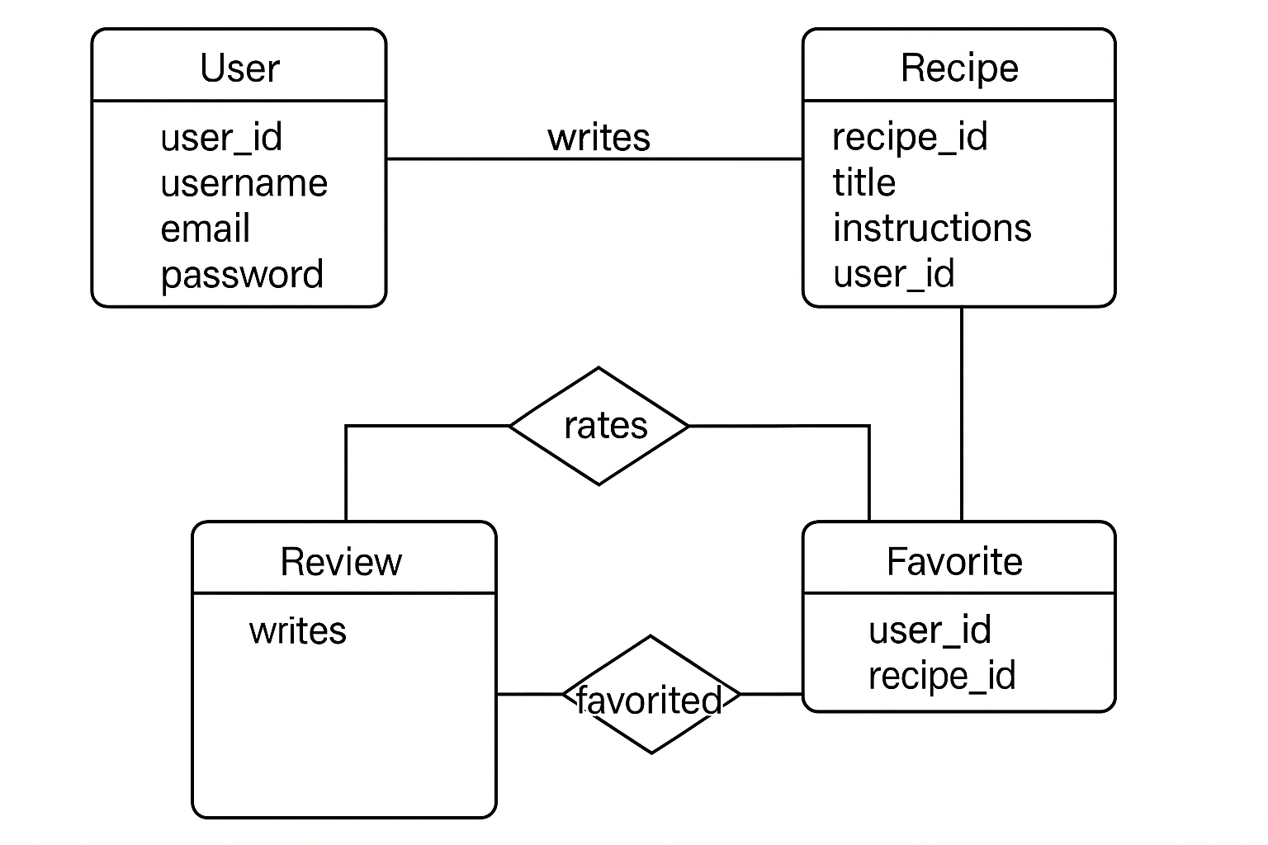

Fig 2: Entity Relationship (ER) Diagram

### **UML Class Diagram (Simplified)**

The UML diagram captures the object-oriented structure of the system in terms of classes and their attributes. While our application uses Flask and Python (which are less rigid about classes), the UML representation helped us think modularly about:

* Encapsulation of recipe logic
* Separation of concerns between users, recipes, reviews, and favorites
* Defining interfaces between form handling, route controllers, and database models

Each class (e.g., User, Recipe, Review, Favorite) contains key fields and illustrates associations such as "a user writes a review" or "a recipe has many reviews." This diagram was instrumental in planning the backend logic and routes.

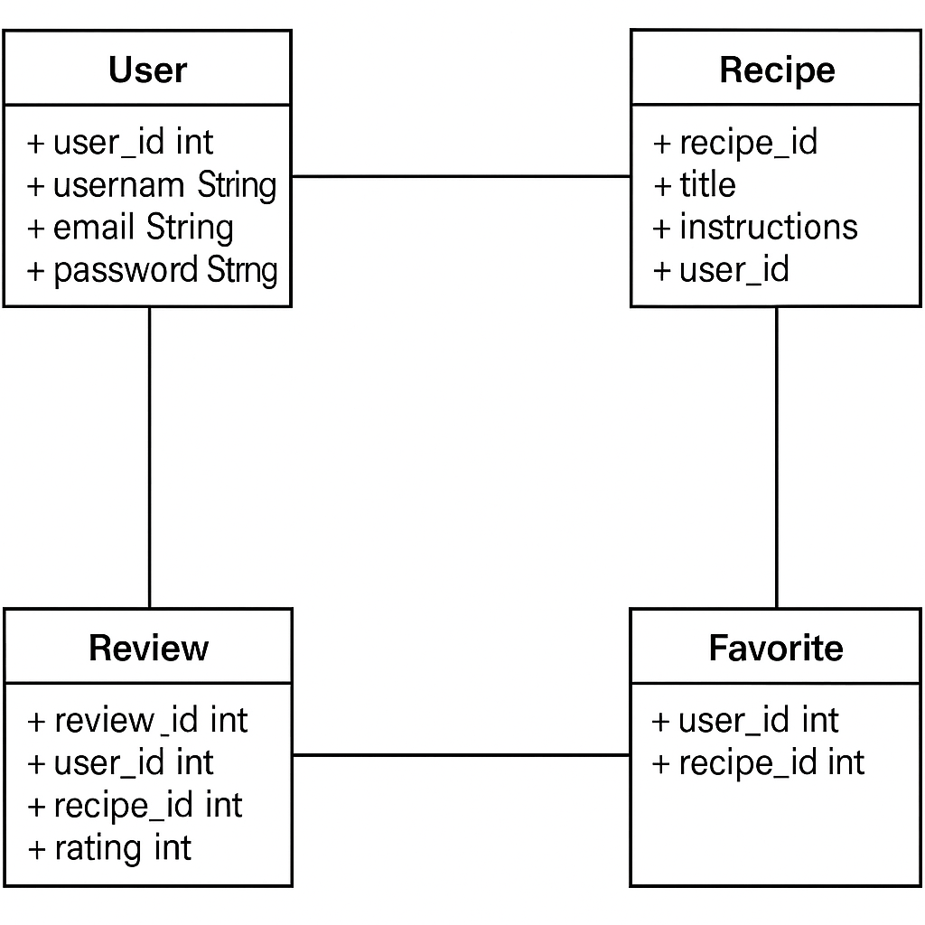

Fig 3: UML Class Diagram (Simplified)

**Testing and Validation**

All feature developments were tested by multiple members before being pushed onto the Cassini servers in order to ensure that the web application remains active and responsive at all time, without causing any bad user experience. Many of the tests conducted revolved around testing/validation if user specific features were functional and saved the information that it should. For example, validation on viewing if favorites are always properly saved for each user as well as ensuring to see the recipes that one specific user shared remain present throughout all changes and progress. Furthermore, through different discussions with our shareholders, improvements were implemented to ensure satisfaction in the product. For example, our shareholder suggested the implementation of different buttons that allows the navigation of the web application easier for all users. These were implemented on all various pages and tested to ensure that the desired behavior occurred once pressed. As the web application delivers a sharing platform for recipes, the testing conducted throughout the development mainly focussed on the functionality and responsiveness of all implemented features.

**Result and Evaluation**

In the grand scheme of things, the project was greatly successful as all of the initial features that were intended to be implemented have been fully developed and improved to allow for a smooth experience. We are extremely proud of the entire development process and deployment of our web application as we strongly believe that all the goals and objectives we set were satisfied. User and shareholder satisfaction represents the key metric used to determine the success of our project. By receiving feedback from both users and shareholders, we were able to conduct improvements when necessary as well as gather a good idea of the success of our project. In the future, we intend to monitor user satisfaction and feedback, thus allowing further improvements and development in the web application.

Development of the web application has taught us valuable lessons and skills that will allow all of us to enhance our developer skills. From learning to effectively work as a team behind a shared goal, to following a timeline to develop and implement key features, we all learn that collaboration helps enhance the success of a project. Collaboration is not limited to participation, but also to knowledge sharing which helps all members develop their skills as web developers. Furthermore, in retrospective, despite having a slower development start, our group quickly learned how to effectively progress through the challenges faced.

**Future Works and Recommendations**

While all features that were originally intended to be developed were implemented to the web application, we are aware that some features can be enhanced through the use of AI or further development. For example, some of the filtering options could benefit from the use of AI to identify key characteristics and patterns across recipes from similar ingredients and/or culture. Therefore, future work ideas would be to implement AI systems to allow for even more filtering options rather than being limited to fixed options that are entered while posting a recipe.

Furthermore, we wish to continue enhancing the performances of the web application by listening to user feedback and correcting bugs that may be found with the use of the application in the near future. A key focus of our project was placed on the user experience, therefore we want to ensure that all users are satisfied with the product we delivered through the course of this Capstone project.

**User Manual**

Users can access the Recipe Hub web application by following this link: <http://crowdrecipe.kentcs.org:8925/>. Once a user access the website, a welcome page will pop up. For first time users, navigate to the “Sign-up” section to create an account. The user will be asked to enter account information there:  
Once an account is created, or for returning users, navigate to the “Login” page to access the personal account and be redirected to the recipe home page: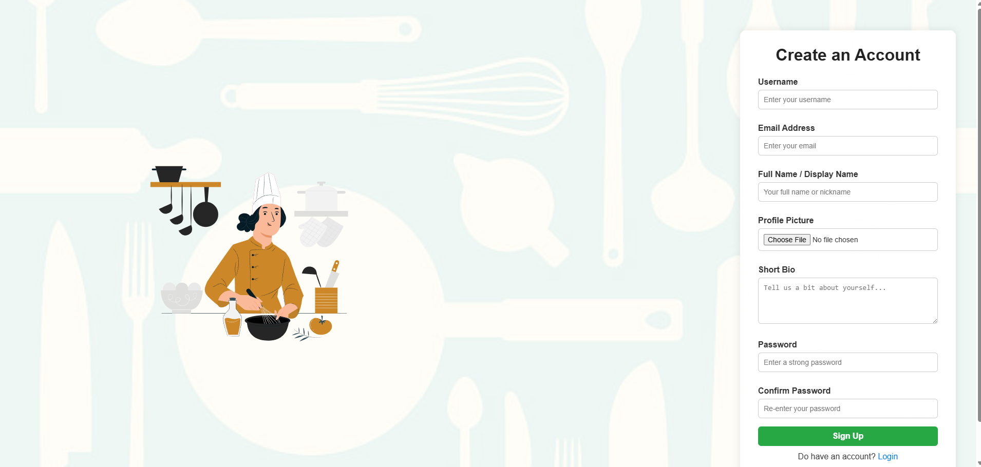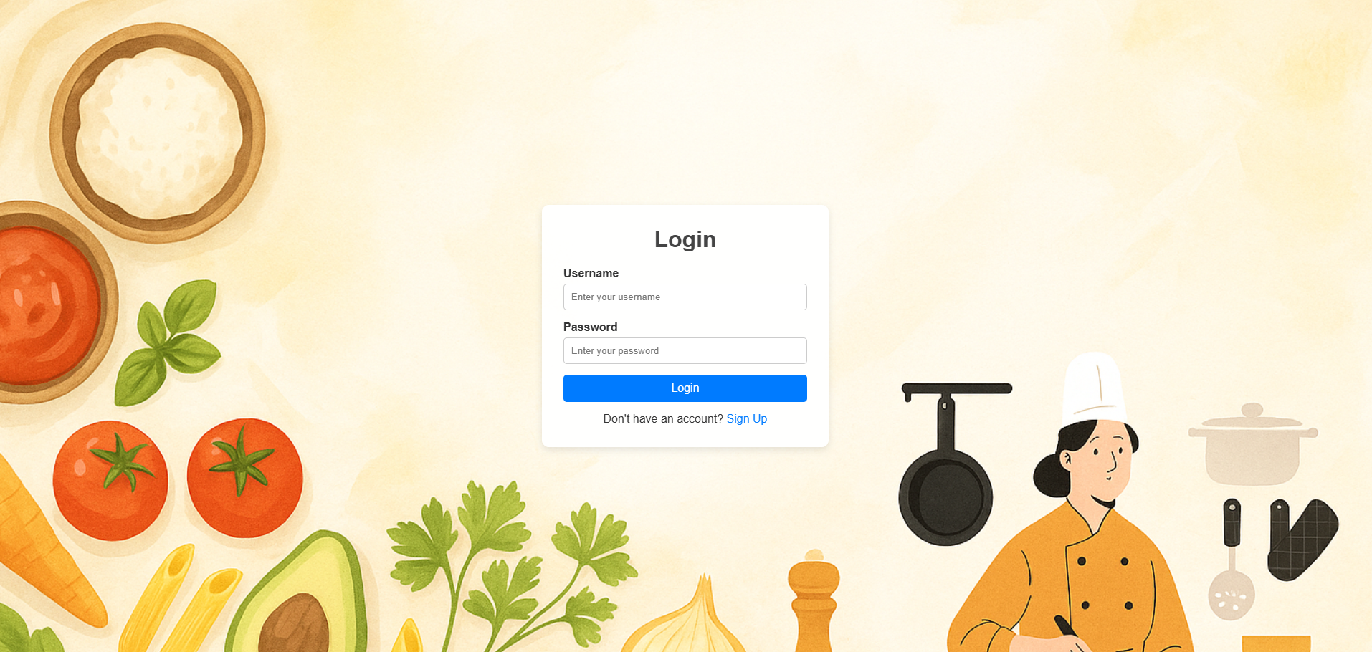

Once logged in, recipes that have been shared before will appear for the user to view and explore based on their interests. A “Try our recipes today” section will rotate through all the recipes (based on filters) for users to quickly access any recipes without needing to scroll through the web page. Furthermore, a multitude of filters are available for the user to select which will filter recipes based on the selected criterias. Such filters include search feature, cuisines, popular, healthy & diet, meal type, and recipe rating filters. The home page appear as so to users:  
By navigating the home recipe page, a user can open any recipe they wish to explore by clicking on the “View Recipe” button, which will open the individual recipe page for the selected option. On this page, the user will see all instructions (and any accompanying video) that will allow them to recreate the recipe at home with no issue. Additionally, several other features will be available for the user. These include to select the desired serving size, rate the recipe, write comments, view & reply to any comments posted, save the recipe to their “favorites”, download the recipe to their computer, print as pdf, and share the recipe via email. The individual recipes page will appear to the user as follows: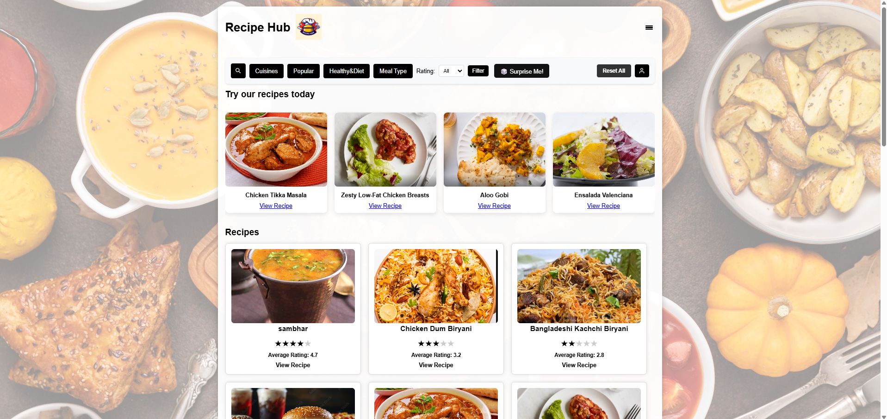

Furthermore, by using the drop down menu of the home page, users can select the option to view recipes they saved as favorites, post any recipes, and logout from the web application. The “favorites” page represents a recreation of the home recipe page, but will only depict the recipes the logged in user has saved as their favorites. All features on the home recipe page will be available to the user as well. This page appears as follows: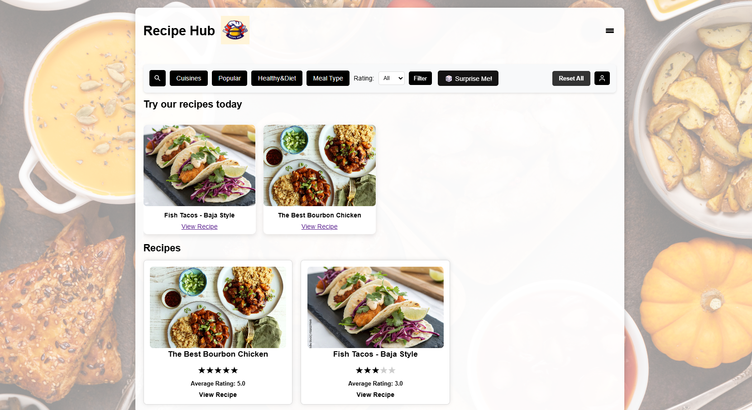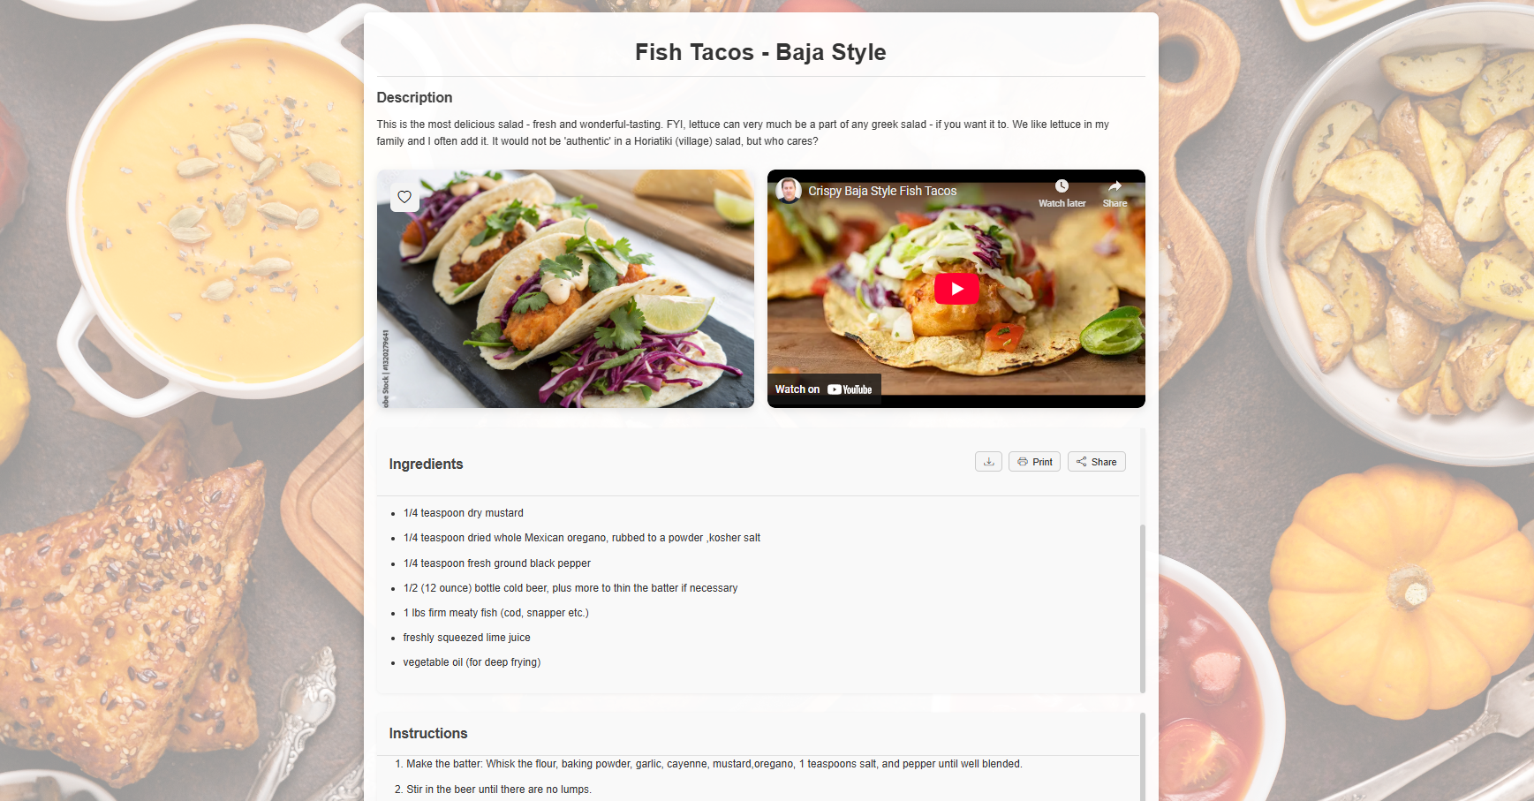

In the same drop down menu, users can select “Post a recipe” so that they can share recipes they are proud of and want to share with the community on Recipe Hub. The template to post a recipe is presented in an easy to follow format, so that all users have an easy time to share their love of the culinary world to the community. The page appears as follows:  
Furthermore, users can click on the “Surprise Me!” button in order to be directed to a randomly generated recipe by theMealDB api. On this page, users can follow the randomly generated recipe as well as select the option to receive a new recipe, or return to the home recipe page. Instructions, ingredients, and an accompanying video will be provided for the user to recreate the recipe at home with ease. Lastly, users can click on the “person” icon in order to access their profile information. This page allows users to view all recipes they personally shared on Recipe Hub, change their password by following the traditional password change process, and edit their profile (where they can change their username, email, full name, update their bio, and add/update a profile picture). All profile updates will be applied once the user hits “Update Profile” at the bottom of the screen. The page is as follows:  
By following the listed elements above, the users will be able to easily and quickly navigate the web application. An important priority during the development of the project was to create a simple user experience, which would allow any users to use Recipe Hub regardless of their technological background.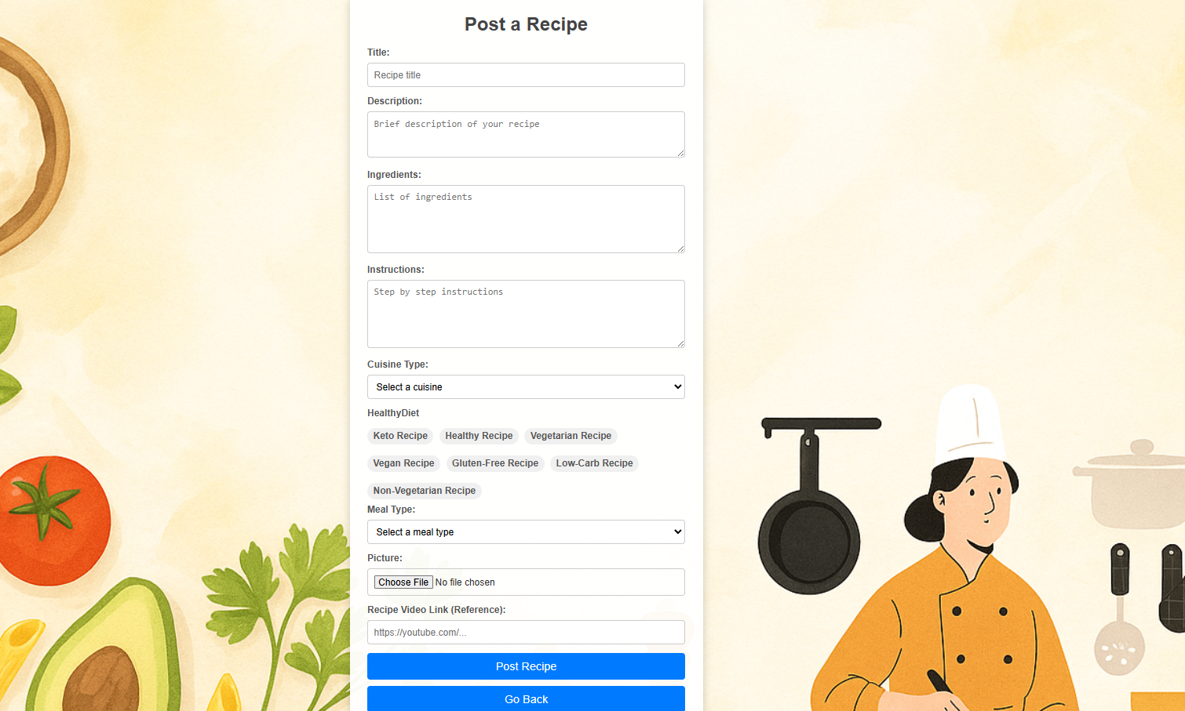

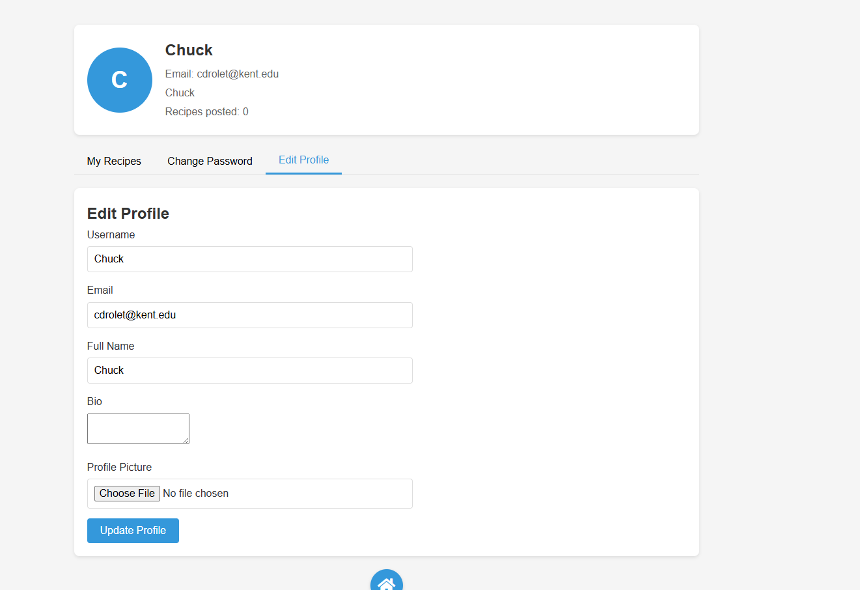

### **Appendix A: URLs for Deployed Products or Code Repositories**

* **Deployed Web Application:** 🌐<http://crowdrecipe.kentcs.org:8925/>
* **GitHub Repository:** 💻<https://github.com/Kawsher/CrowdSourceRecipe>